Posted 10/25/2011 at 2:43 pm by JAV

Municipal Building Committee

Agenda
Old Library, Fireplace Room
Tuesday, Nov. 1, 2011
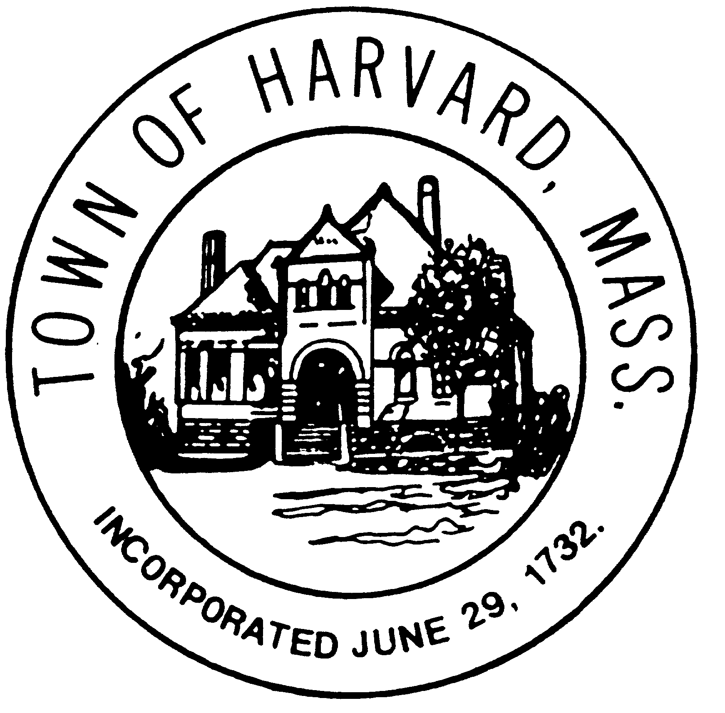
7:30 AM

- Approve minutes

- Prepare interview questions for short listed architects

- Agenda for next meeting

